Uber registration

The description is made on 26/09/2018.

1. To register an account with Uber Ride, please go to https://www.uber.com/.

2. Click the "Sign up to ride" button.

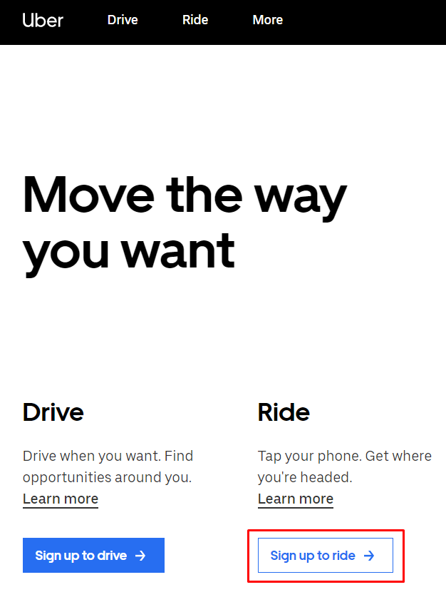

3. In the form that opens, fill in the required fields and click on the "SIGN UP" button. In this way, you will register a new account.

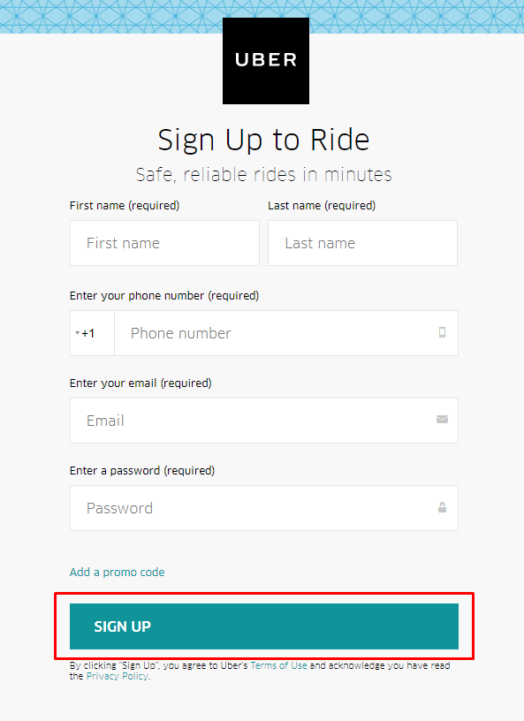

4. Download the mobile Uber application and log in to it. This way you will confirm your account.

5. To register the application in the Uber service, go to https://developer.uber.com.

5. Press the "SIGN IN" button.



6. Enter your registered e-mail or phone number and click on the "NEXT" button.

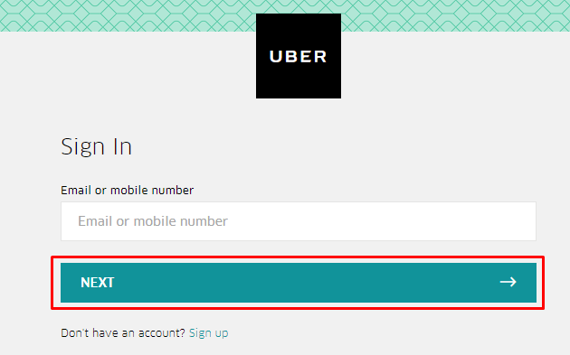

7. Next, enter your password and click on the "NEXT" button.

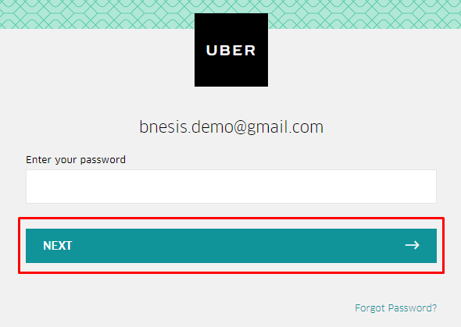

8. In the window that opens, click on the "register App" button.



9. Specify the name of the application and make its description, accept the terms of use and click on the "Create" button.

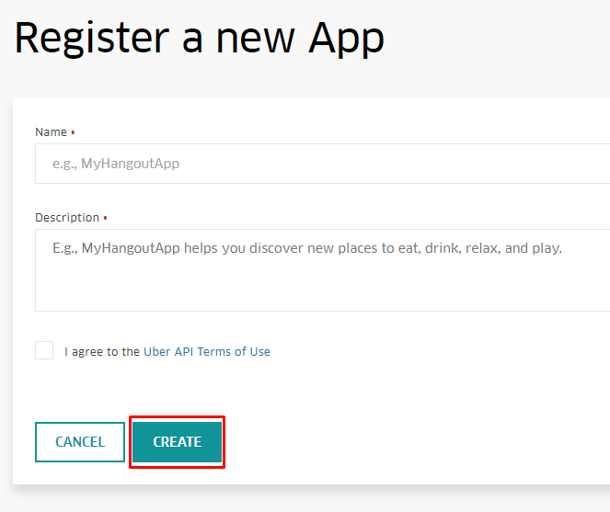

10. In the window that opens, specify ‘Redirect URI’ and ‘Privacy Policy URL’.

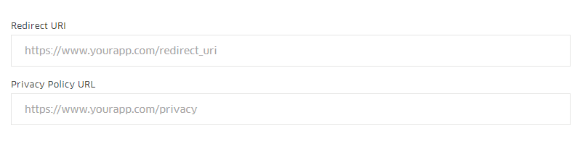

11. Mark the permissions you need.

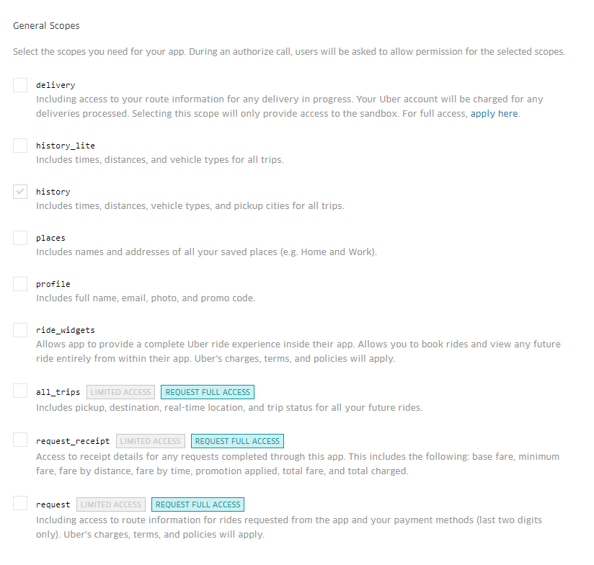

12. At the bottom of the page, click on the "SAVE" button.



13. Now you can use the Client ID and Client secret provided to you to call the service API.

